Question 3:
Attributes:
According to the assignment specification, there are 3 entities with the respective attributes:
- University
  - Name
    - The ‘Name’ field is a string and hence has been given the data type ‘CharField’ with max length ‘255’.
- School
  - Name of School
    - The ‘Name of School’ is a string and hence has been given the data type ‘CharField’ with max length ‘255’.
  - Head of School
    - The ‘Head of School’ is a string and hence has been given the data type ‘CharField’ with max length ‘255’.
- Course
  - Course Name
    - The course name is a string and hence has been given the data type ‘CharField’ with max length ‘255’.
  - Coordinator
    - The coordinator name is a string and hence has been given the data type ‘CharField’ with max length ‘255’.
  - School Name (Foreign key)
  - Credits (I thought it relevant to include this)
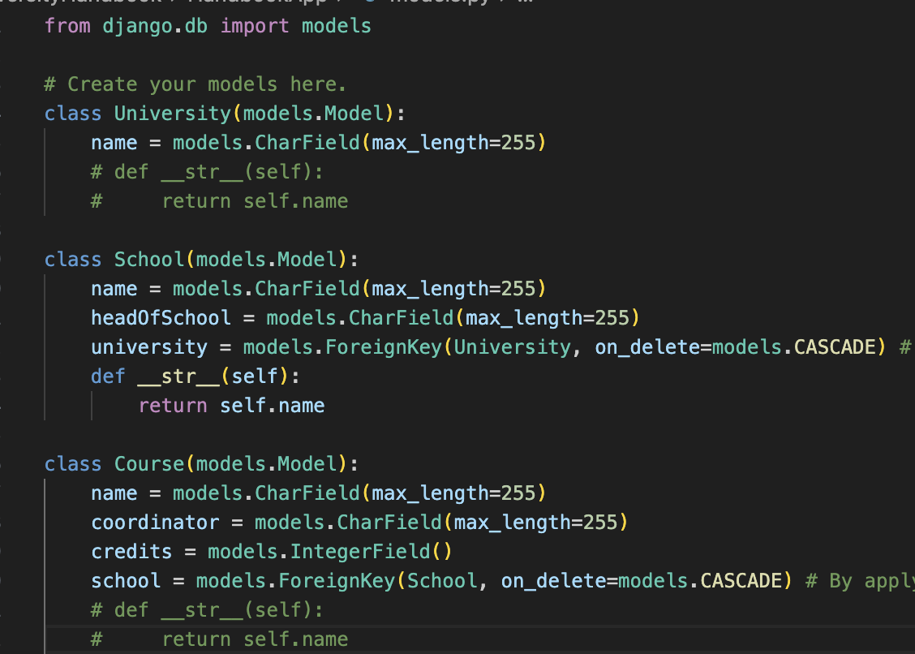
    - Credits are numeric integer values and has hence been given the data type ‘IntegerField’

As you can see, the ‘University’ attribute in the School entity is a foreign key. This means that a University can have multiple schools, whilst schools can only have one University, creating a one-to-many relationship. The University attribute is representative of the location specified in the assessment specification.
The same has been done for the Course which has the foreign key School, creating a one-to-many relationship, where schools can have many courses, whilst a course can only have one school.

Question 9:
Head of School:
Restrict them to CRUD operations in their relevant school and the courses associated with it only. They would not be able to modify other schools information and would only be able to read/view other schools information. If for security purposes, perhaps a second approval for ‘Delete’ operations is required (optional).
Course Coordinator:
I would restrict the course coordinator to allow for all CRUD operations for the courses they are coordinating only, courses they are not coordinating, whether or not it is within their school or not, they will only be able to view. Course coordinators will not be able to modify information about their school and courses outside of their domain, they will only be limited to viewing them.
Once again, we could optionally implement having two signatures/approvals required for deletion of a course as this will remove things permanently but this is optional.
Website visitors:
Website visitors would only be able to read information on the website, this website does not have any information to be stored from users as this is a coursebook/handbook of sorts, there is no enrolment, and hence no creation of information.

Question 10:
One benefit of using Django as opposed to raw HTML, CSS, and JS is the use of Dynamic HTML blocks. We are able to change information displayed without having to create entirely new HTML files and pages, this allows for the rapid development of web applications.
Another benefit is security. With Django, we have a lot of security features. Using templates in Django protects you from many XSS attacks. XSS or Cross Site Scripting is an attack where a user with malicious intent injects client side scripts into the browsers of other users. This is achieved by storing scripts in the database where other users will unknowingly retrieve these scripts and be executed in their browser. By using templates, Django is able to protect users against the vast majority of XSS attacks and other vulnerabilities.

